**“Experiment – 7”**

Name: **SUMIT KUMAR** UID: **20BCS8226**

Branch: **BE-CSE** Section/Group: **MM 808 A**

Semester: **5th** Date of Submission: **10/11/22**

Subject Name: **Machine Learning Lab** Subject Code: **20CSP-317**

**1. Aim/Overview of the practical:**

Implement Decision Tree and compare the performance with Random Forest on any data set.

**2. Task to be done/ Which logistics used:**

Implement Decision Tree and compare the performance with Random Forest on any data set.

**3. Steps for experiment/practical/Code:**

from google.colab import drive

drive.mount('/content/drive')

import pandas as pd

data = pd.read_csv('/content/drive/MyDrive/Data/data.csv')

print(data)

d = {'UK': 0, 'USA': 1, 'N': 2}

data['Nationality'] = data['Nationality'].map(d)

d = {'YES': 1, 'NO': 0}

data['Go'] = data['Go'].map(d)

print(data)

features = ['Age', 'Experience', 'Rank', 'Nationality', 'Go']

x = data[features]

y = data['Go']

print(x)

print(y)

from sklearn import tree

from sklearn.tree import DecisionTreeClassifier

import matplotlib.pyplot as plt

dtree = DecisionTreeClassifier()

dtree = dtree.fit(x,y)

tree.plot_tree(dtree, feature_names=features)

print(dtree.predict([[40, 30, 10, 7, 1]]))

**4. Result/Output/Writing Summary:**

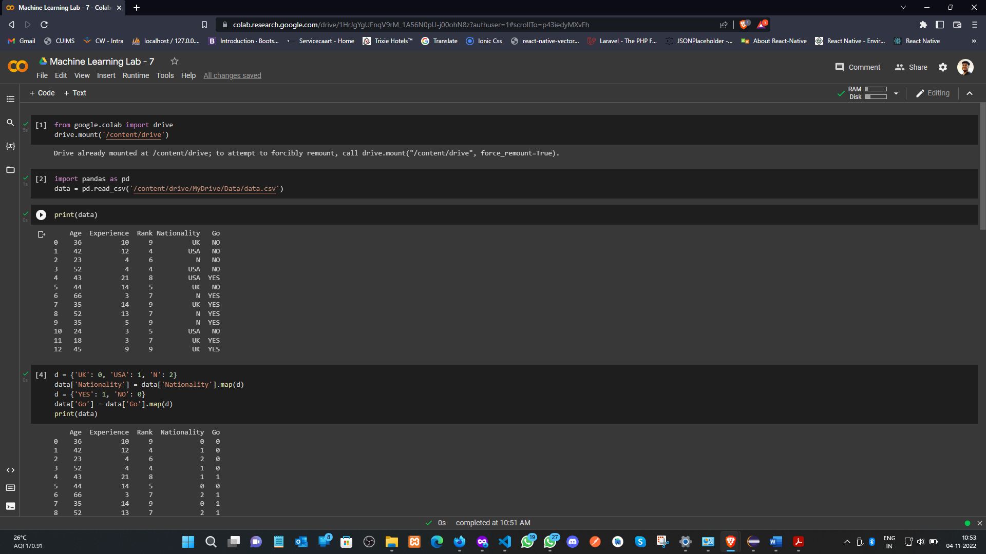

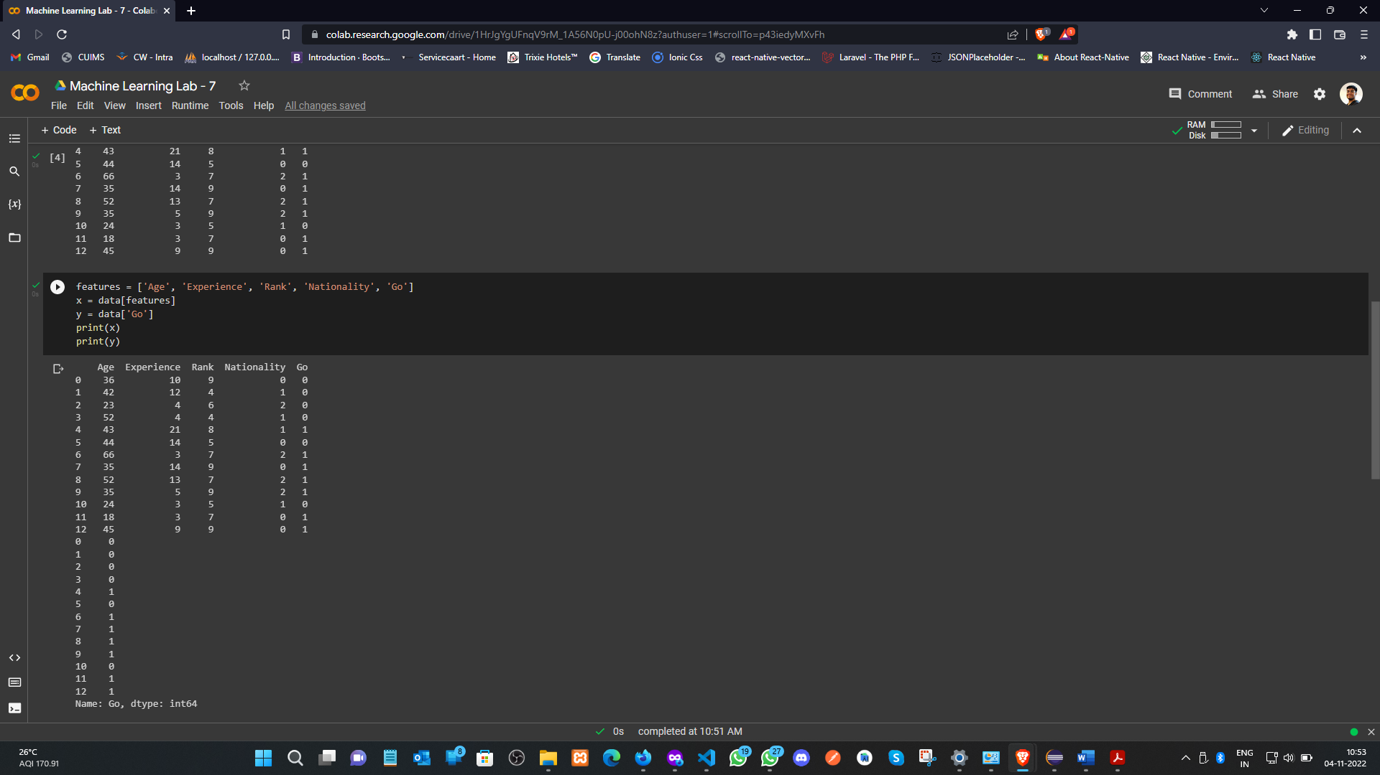

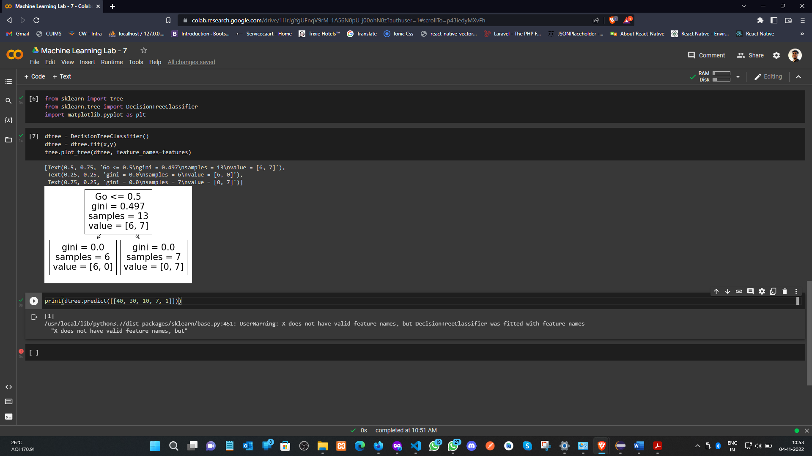

**Learning outcomes (What I have learnt):**

1. Understood the concept of Decision Tree.
2. Learnt how to load the dataset and map it.
3. Printing the data according to the feature available in the dataset.
4. Plot the Decision Tree and predict it.

**Evaluation Grid (To be created as per the SOP and Assessment guidelines by the faculty):**

|  |  |  |  |
| --- | --- | --- | --- |
| Sr. No. | Parameters | Marks Obtained | Maximum Marks |
| 1. |  |  |  |
| 2. |  |  |  |
| 3. |  |  |  |
|  |  |  |  |